ADDENDUM #3
RFQ # 051917
Date Issued: Tuesday, June 20, 2017 - Proposal Due Date: June 22, 2017

- General – Can we get a short extension on the deadline?

Answer: If a second vendor also requests an extension prior to June 22nd, an extension will be granted to all proposers.

- Section 2.3 – Alternate proposals, what is the baseline for initial comparison?

Answer: The baseline for the initial comparison is: the necessary hardware and software to satisfy Section 3.1 with the minimum specifications found in Section 3.3 and 3.4. It is strongly suggested for proposers to provide a detailed itemized pricing schedule. Once the initial comparison is completed, alternate options can be completed in blue in accordance with the RFP.

- Section 3.1.2 – Can you verify the capabilities of the existing point to point that is integrated with the
library along with the up-time and reliability?

Answer: The point to point wifi system utilized at the lot is achieved through a Ruckus Zoneflex 7731 bridge. The wifi is portioned off of the library’s access to the state’s CEN. There is sufficient bandwidth to provide LPR, credit card, VoIP, and video support. The uptime has averaged between 98-99%. Reliability primarily depends on library IT staff maintaining cognizance of our system while conducting maintenance activities.

- Section 3.2 – Should we include replacing all equipment in the base proposal with alternates in electric
blue to re-use where possible? In addition, do you require a warranty on any re-used equipment?

Answer: Yes, include replacing all equipment in the base proposal and reusing any existing equipment as an alternate in blue in accordance with the RFP. It is expected that all reused equipment will only be utilized if it is in good working order and have an ample replacement part availability. To facilitate this expectation, proposers should provide a reasonable warranty.

- Section 3.5 – Should the three-year warranty be included in the base bid, or as an option to add?

Answer: Please provide in your base proposal the standard warranty, as well as a priced line item for any additional warranty necessary to achieve the requirements stated in the RFP.

- General – Is the City of Hartford supplying the network, switches, and firewalls or is the vendor supplying?

Answer: As stated in Section 3.3, the Proposer will provide all necessary hardware including network equipment. Further, all network equipment must be commercial grade. HPA will only provide the data plan.

- General – Can I see a picture of the box label that is on the proximity card box?

Answer: The garage operator does not have any boxes available. However, the proximity card is very similar in nature to the below.

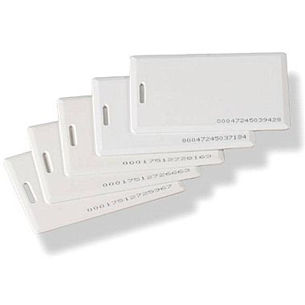

END OF ADDENDUM # 3

